Experiment: 7
Analysis of 5G NR Frame Structure and Subcarrier Spacing

Objective – 1: Generate / Inspect a Simplified 5G NR Resource Grid
Program:
clc; clear; close all;
Nsc = 24; % Simplified number of subcarriers
Nsym = 14; % OFDM symbols per slot
grid = zeros(Nsym,Nsc);
% Simplified DL assignment: symbols 1-10
grid(1:10,:) = 1;
% Simplified UL assignment: symbols 11-14
grid(11:14,:) = 2;
figure
imagesc(grid)
grid on
xlabel('Subcarrier Index')
ylabel('OFDM Symbol Index')
title('Simplified 5G NR Time-Frequency Resource Grid')
colorbar
Expected Output: A time-frequency grid representing simplified downlink and uplink
resource assignments.
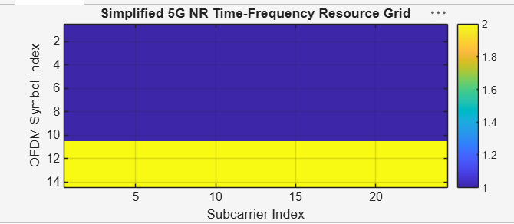
Objective – 2: Compare SCS and Slot Duration

Program:
clc; clear; close all;
scs = [15 30 60 120 240]; % kHz
mu = 0:4;
slot = [1 0.5 0.25 0.125 0.0625]; % ms
figure
plot(scs,slot,'o-','LineWidth',2)
grid on
xlabel('Subcarrier Spacing (kHz)')
ylabel('Slot Duration (ms)')
title('5G NR Slot Duration for Different Subcarrier Spacing')
figure
bar(scs)
grid on
set(gca,'XTickLabel',mu)
xlabel('Numerology Index (\mu)')
ylabel('Subcarrier Spacing (kHz)')
title('5G NR Subcarrier Spacing for Different Numerologies')
Expected Output: Slot duration decreases as SCS increases. The SCS graph shows 15, 30, 60,
120 and 240 kHz.

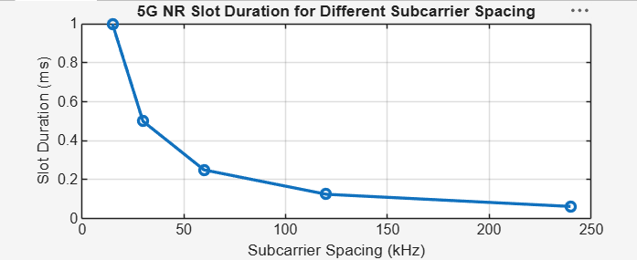Figure 7.2: 5G NR Slot Duration for Different Subcarrier Spacing
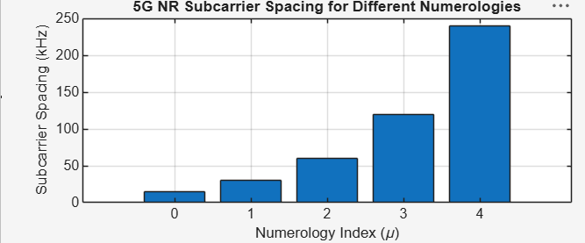
Objective – 3: Identify Basic DL and UL Resource Assignments

Program:
clc; clear; close all;
symbols = 1:14;
DL = [1 1 1 1 1 1 1 1 1 1 0 0 0 0];
UL = [0 0 0 0 0 0 0 0 0 0 1 1 1 1];
figure
plot(symbols,DL,'o-','LineWidth',2); hold on
plot(symbols,UL,'s-','LineWidth',2)
grid on
xlabel('OFDM Symbol Index')
ylabel('Allocation Status')
title('Simplified Downlink and Uplink Assignment')
legend('Downlink','Uplink')
Expected Output: A plot identifying simplified DL and UL resource assignments across the
OFDM symbols.
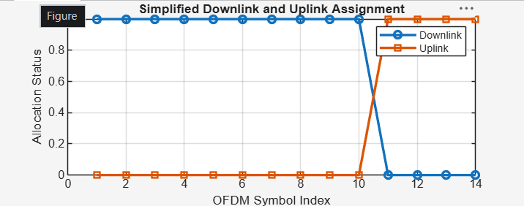
Figure 7.3: Simplified Downlink and Uplink Assignment
Objective – 4: Relate Resources to gNodeB, RAN and RRC
The gNodeB is the principal 5G NR radio access node. It participates in radio-resource
management and scheduling and provides the radio interface between the UE and the 5G
core. RRC is a control-plane protocol responsible for radio-resource configuration and
connection-related control. The simplified grid therefore represents the radio resources that
are scheduled and configured within the RAN; the exact allocation in a live network depends
on traffic, channel conditions, QoS and scheduling decisions.
Result
1. A simplified 5G NR resource grid was generated and inspected.
2. The effect of different SCS values on slot duration was analyzed.
3. Basic downlink and uplink resource assignments were represented.
4. The relationship among NR radio resources, gNodeB operation, RAN organization and
RRC was explained.

